Learning Deliberative Capacities in Brazilian Schools - Appendix

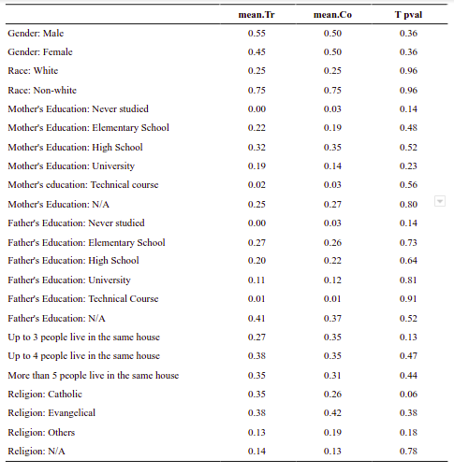
Table A1: Balancing of control and treatment groups

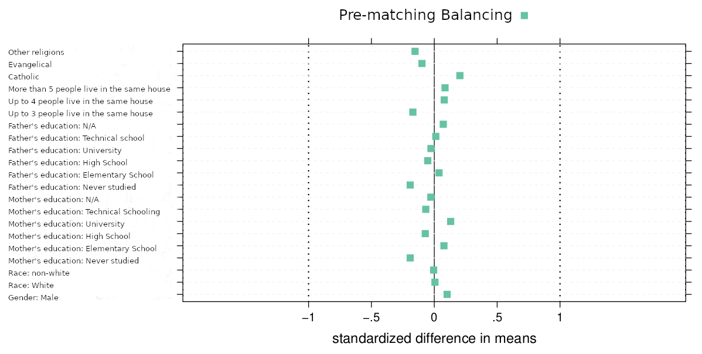
Figure A1: Balancing of control and treatment groups

 | School Classes** | Small groups in  Classrooms |  | Number of participants in small groups
Control Group | FM-C | A |  | 10
 |  | B |  | 10
 | MC-C | A |  | 9
 |  | B |  | 12
 |  | C |  | 11
 | Subtotal middle-class context |  | 52
 | LA-C | A |  | 12
 |  | B |  | 12
 |  | C |  | 11
 | RV-C | A |  | 5
 |  | B |  | 8
 | Subtotal vulnerable context |  | 48
Treatment Groups | FM-1 | A |  | 12*
 |  | B |  | 12
 |  | C |  | 12
 | FM-2 | A |  | 11
 |  | B |  | 10
 |  | C |  | 11
 | MC-1 | A |  | 14
 |  | B |  | 13
 |  | C |  | 12
 | MC-2 | A |  | 7
 |  | B |  | 13
 |  | C |  | 8
 |  | D |  | 9
 | Subtotal middle-class context |  | 144
 | LA-1 | A |  | 12
 |  | B |  | 13
 | LA-2 | A |  | 20
 |  | B |  | 12
 | RV-1 | A |  | 9
 |  | B |  | 10
 | RV-2 | A |  | 10
 |  | B |  | 12
 | Subtotal vulnerable context |  | 98

Table A 2. Number of participants per small group in the first discussion event
*Not considered in the analysis. Records of the second discussion event are missing.
**In order to preserve anonymity, we identified the schools by letters and numbers, with those ending with the letter "C" representing the control classes.
 | School Classes** | Small groups in  Classrooms | Number of participants in small groups
Control Group | FM-C | A | 10
 |  | B | 10
 | MC-C | A | 9
 |  | B | 12
 |  | C | 11
 | Subtotal middle-class context |  | 52
 | LA-C | A | 12
 |  | B | 12
 |  | C | 11
 | RV-C | A | 8
 |  | B | 10
 | Subtotal vulnerable context |  | 53
Treatment Groups | FM-1 | A | 9*
 |  | B | 9
 |  | C | 10
 | FM-2 | A | 13
 |  | B | 6
 |  | C | 9
 | MC-1 | A | 13
 |  | B | 13
 |  | C | 9
 | MC-2 | A | 5
 |  | B | 8
 |  | C | 8
 |  | D | 8
 | Subtotal middle-class context |  | 120
 | LA-1 | A | 9
 |  | B | 13
 | LA-2 | A | 11
 |  | B | 6
 | RV-1 | A | 10
 |  | B | 9
 | RV-2 | A | 10
 |  | B | 12
 | Subtotal vulnerable context |  | 80
Table A 3. Number of participants per small groups in the second discussion event
*Not considered in the analysis. Records of the second discussion event are missing.

Statistical analyses
The use of two tests - The Z-test and Difference in Difference test (DiD) - was important to obtain more accurate results. The Z-test was chosen because it fits the structure of our data and respects our study's assumptions, category variables, and sample size (does not need to be used with large samples). This test checks for a statistically valid difference in the proportion of our analytical categories in the two discussions and also has excellent accuracy for samples with different sizes.
$z=\frac{{ρ^}_{1}-{ρ^}_{2}}{\sqrt{\underline{ρ}\left(1-\underline{ρ}\right)\left(\frac{1}{n_{1}}+\frac{1}{n_{2}}\right)}}$
We considered a significance level of 5%, that is, we consider the test to show statistically different proportions for a category when the P-values ​​are smaller than 0.05. We adopted the following hypothesis:
H0: Discussion Event 1 – Discussion event 2 = 0 (Null hypothesis)
H1: Discussion Event 1 – Discussion event 2 ≠ 0 (Alternative hypothesis)
In cases where the Z-test showed proportions that were significantly different between the first and second discussion event, we used the DiD test to estimate the treatment effect on the treated students. Since the DiD enables us to calculate the difference between the two proportions, it makes sense to perform it only when the Z-test shows a significant difference in them. That is: Treatment = T1 – T0; Control = C1 – C0
When the Z-test showed no significant difference in the proportions of the first and second discussion events, the DiD will also not have a significant difference. On the other hand, when the Z-test shows a significant difference, it does not imply that the DiD will necessarily be significant, but it is more likely to be. As the same sample was used in both tests, we were able to obtain consistent results
DD = (yT1 – yC1) – (yT0 – yC0)
Data from both groups (Control and Treatment) before and after the intervention is required. That is: C0 – control before; C1– control after; T0 – treatment before; T1 – treatment after.

