Appendix 1. The Optimal Number of Topics

A key step in STM involves specifying the hyperparameter K, which controls the number of topics to be estimated before training the model. STM belongs to a class of unsupervised statistical topic models that infer the topical structure of the collected documents (Roberts et al., 2014). Two measures can be used to assess the quality of model’s outcomes (Roberts et al., 2014, 2019). First, exclusivity measures the degree to which the keywords in one topic do not appear in other topics, ensuring that topics are distinct from each other. Second, semantic coherence measures the degree to which the keywords of each topic frequently co-occur within documents. When selecting K, researchers should aim for a balance between high exclusivity and coherence to ensure semantic interpretability (Roberts et al., 2014). Figure 1 plots exclusivity and semantic coherence scores for varying K parameters, indicating that models within the range of 15 to 20 topics achieve optimal results when both criteria are considered. After manually inspecting the parameters, the 17-topic model was chosen as the most appropriate.

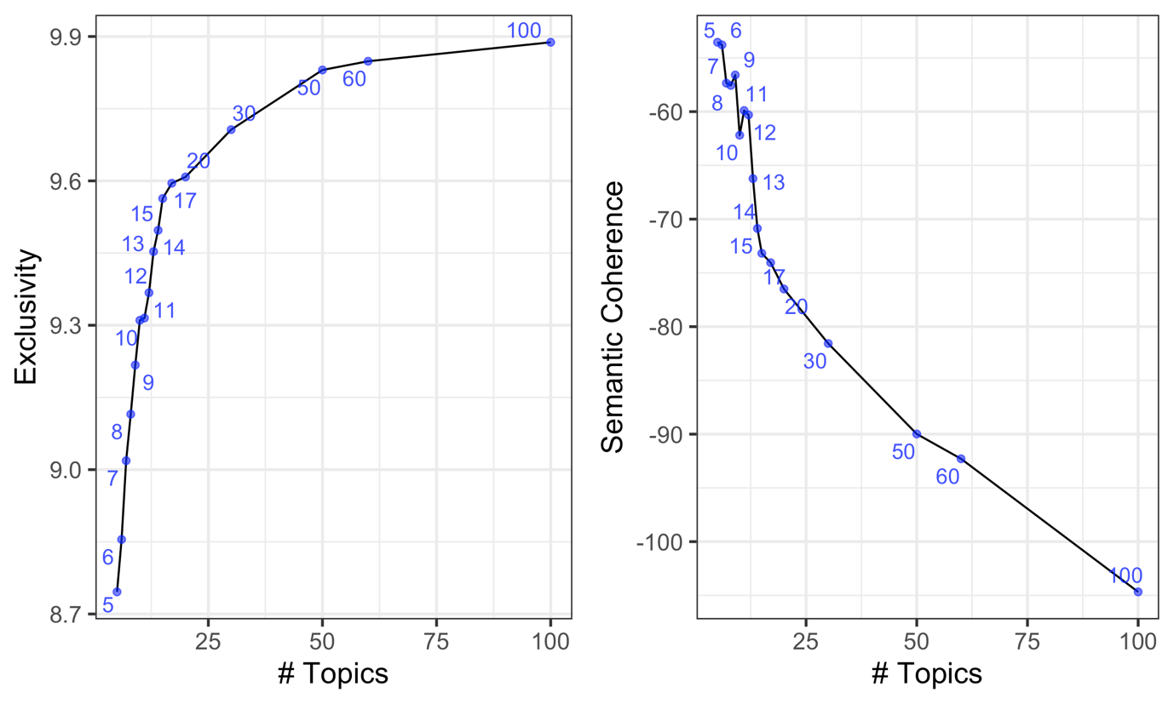
Figure 1. Exclusivity and semantic coherence.

